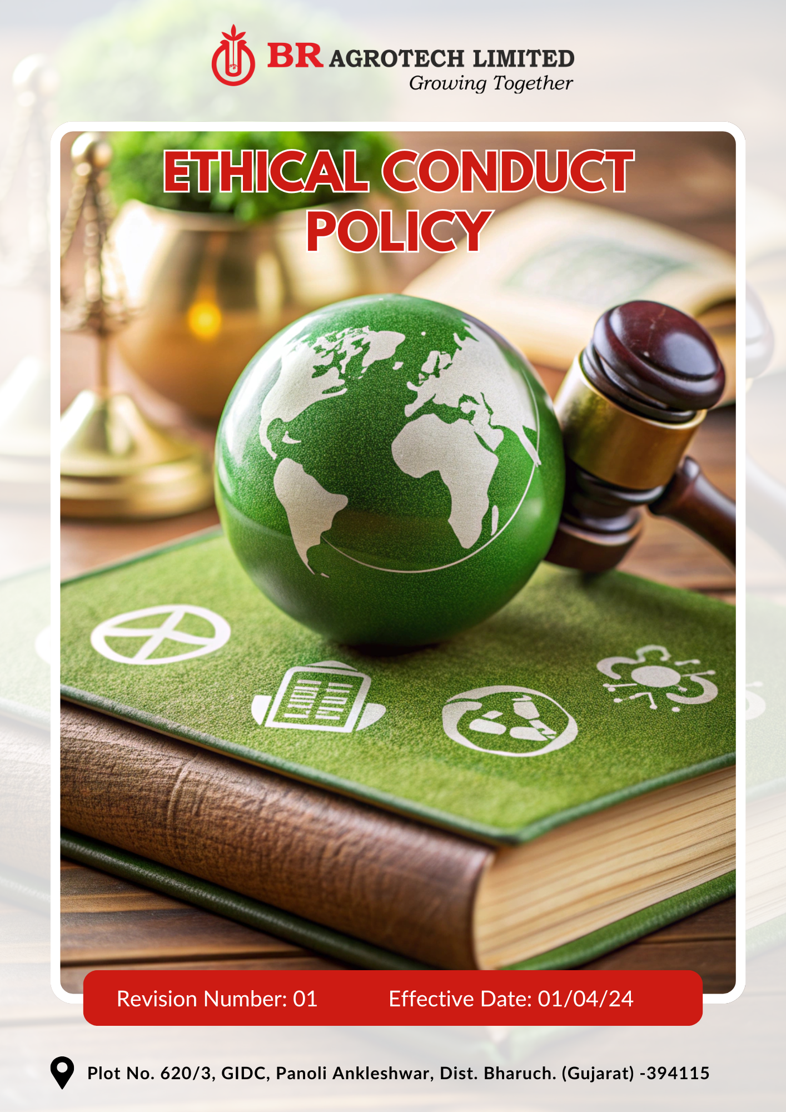
Contents

Preface 3
Policy Declaration 3
Scope 3
Ethical Conduct Standards 4
Our Performance Targets 4
Alignment with the United Nations Sustainable Development Goals (SDGs) 5
Responsibilities 5
Continuous Improvement 6
Addressing Policy Violations 6
Monitoring, Reporting, and Review Mechanism 6
Employee Acknowledgment Form 8

Preface
We at BR Agrotech Limited prioritize ethical business practices, ensuring integrity, transparency, and accountability in all aspects of our operations. We believe that ethical conduct is fundamental for building long-term trust with employees, stakeholders, and business partners. Maintaining ethical business practices helps reinforce corporate credibility, prevent financial and reputational risks, and foster a culture of accountability.

This policy outlines the principles and expectations for ethical behavior across the organization, covering areas such as corruption, conflict of interest, fraud, money laundering, information security, workplace harassment, ethical procurement, responsible marketing, and transparency in financial reporting. It provides a framework for ensuring compliance with all applicable laws, preventing unethical conduct, and encouraging employees to act with honesty and fairness. Through rigorous compliance mechanisms, regular training, and continuous monitoring, we aim to create a work environment that promotes ethical decision-making, responsible business practices, and corporate integrity.

Policy Declaration
BR Agrotech Limited is dedicated to conducting business with integrity, fairness, and transparency. We strictly prohibit corruption, fraudulent activities, and unethical behavior. All employees, suppliers, and business partners are expected to uphold these ethical standards in every transaction and business decision. This policy establishes guidelines to prevent misconduct and reinforces our commitment to responsible corporate governance.

Scope
This policy applies to BR Agrotech Limited’s operations, and it covers following sites and all its employees, workers, subcontractors and other stakeholders:

Site | Address
BR Agrotech  Limited | Plot No. 620/3, GIDC, Panoli Ankleshwar, Dist. Bharuch. (Gujarat)- 394 115

Ethical Conduct Standards
- Prohibit all forms of bribery, kickbacks, and undue influence in business transactions to ensure fair and ethical practices.
- Ensure employees disclose any personal interests that may interfere with professional responsibilities.
- Strengthen financial oversight by implementing rigorous internal controls, conducting regular audits, and enhancing fraud detection mechanisms.
- Enforce strict anti-money laundering measures, including due diligence, transaction monitoring, and adherence to financial regulations.
- Safeguard sensitive business and customer data through advanced cybersecurity protocols, periodic security audits, and strict access controls.
- Encourage employees to report unethical conduct without fear of retaliation.
- Engage with suppliers and partners who adhere to ethical business practices and compliance.

Our Performance Targets
All performance targets outlined in this policy use FY 2022-23 as the baseline year, serving as a reference point to measure progress, track improvements, and ensure accountability in achieving ethical compliance objectives.
- Strengthen anti-corruption measures through employee training and risk assessments.
- Ensure 100% of employees receive anti-corruption training and maintain the record of zero reported incidents of corruption or unethical financial transactions by FY 2029-30.
- Conduct annual reviews to identify and resolve conflicts of interest proactively.
- Maintain a practice that 100% of employees in managerial roles complete annual conflict of interest disclosure forms.
- Achieve 100% compliance with disclosure requirements for senior management by FY 2029-30.
- Enhance internal controls and conduct regular financial audits to detect and mitigate fraudulent activities.
- Maintain zero fraud-related incidents through enhanced internal controls and implement mandatory fraud detection training for 100% of finance and procurement employees by FY 2029-30.
- Establish strict due diligence protocols for all financial transactions and business dealings to reduce money laundering related risks.
- Continuously enhance information security frameworks by integrating advanced threat detection systems and regularly revising security protocols to counter emerging cyber risks.
- Ensure 100% of employees undergo cybersecurity awareness training annually.
- Ensure 100% of high-value transactions undergo enhanced due diligence checks to mitigate money laundering risks by FY 2029-30.
- Implement multi-factor authentication across all company systems by FY 2029-30 in order to ensure information security.
- Maintain zero phishing and cyberattack incidents through employee training and security enhancements

Alignment with the United Nations Sustainable Development Goals (SDGs)
The sustainability commitments and performance targets align with the following Sustainable Development Goals (SDGs):
- SDG 8: Decent Work and Economic Growth – Strengthening anti-bribery, fraud prevention, and ethical financial practices to promote a transparent work environment.
- SDG 9: Industry, Innovation, and Infrastructure – Strengthening cybersecurity frameworks and adopting advanced security measures to enhance digital resilience.
- SDG 10: Reduced Inequalities – Enforcing anti-corruption and conflict of interest policies to ensure fair opportunities and ethical business conduct.
- SDG 16: Peace, Justice, and Strong Institutions – Strengthening anti-money laundering measures, whistleblower protection, and financial transparency to uphold institutional integrity.
- SDG 17: Partnerships for the Goals – Partnering with financial and regulatory bodies to enhance compliance and promote ethical business networks.

Responsibilities
- Site Head: Ensure policy implementation and allocate resources for ethical compliance programs. Implement internal controls and ethical business practices.
- Human Resource Team: Monitor policy adherence, conduct investigations, and oversee training programs.
- Employees: Adhere to ethical guidelines, report misconduct, and participate in compliance training.
- Suppliers & Business Partners: Align business operations with BR Agrotech’s ethical conduct policies and compliance standards.

Continuous Improvement
BR Agrotech Limited is committed to enhancing ethical business practices through periodic assessments, stakeholder feedback, and alignment with evolving regulatory standards. The company will conduct regular policy reviews to integrate industry best practices, technological advancements, and compliance updates. Employees and stakeholders are encouraged to provide recommendations for policy enhancements, ensuring ethical standards remain robust. Ongoing training and awareness programs will reinforce ethical responsibilities and promote a culture of integrity.

Addressing Policy Violations
Any violation of this policy will be addressed through a structured process, including investigations, corrective actions, and disciplinary measures when necessary. Reports of unethical behavior will be thoroughly reviewed, with appropriate consequences ranging from training and warnings to termination of employment or legal action in severe cases. Employees are required to report suspected violations through designated confidential reporting channels, with strict protection against retaliation. BR Agrotech Limited ensures all reported cases are handled with fairness, confidentiality, and due diligence.

Monitoring, Reporting, and Review Mechanism
- The Human Resource Team actively monitors ethical performance by tracking key indicators, conducting internal reviews, and reporting progress annually to senior management. This includes assessing adherence to anti-bribery measures, fraud prevention protocols, conflict of interest disclosures, and information security practices.
- Independent third-party audits and internal assessments are conducted periodically to evaluate compliance with ethical policies, identify gaps, and implement corrective actions. These audits validate adherence to legal regulations, industry best practices, and corporate governance standards.
- This policy will undergo review once in two years or as needed by the Ethics Officer to incorporate emerging best practices, adapt to regulatory changes, and strengthen ethical business practices. Updates will be approved by senior management and communicated across all levels of the organization to ensure continuous improvement and accountability.

Effective Date | : 01.04.2024
Next Review Date | : 01.04.2026
Revision No. | : 01

Approved By :

Employee Acknowledgment Form
I acknowledge that I have read and understood the Ethical Conduct Policy of BR Agrotech Limited. I agree to uphold the ethical standards, principles, and commitments outlined in this policy and to conduct myself with integrity, transparency, and accountability in all professional activities. I understand my responsibility to report any unethical behavior or policy violations through the appropriate channels and actively participate in ethical compliance training. By signing this acknowledgment, I confirm my commitment to fostering a responsible and ethical work environment.

Employee Name | : _________________________
Employee ID | : _________________________
Department | : _________________________
Signature | : _________________________

